Lab 4 – CSE 206

Assignment 1:
- Logic diagram
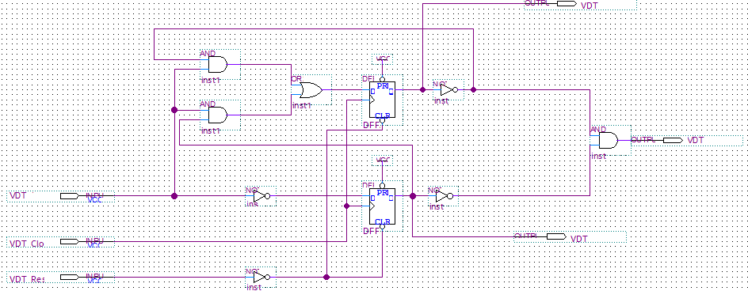

- State table
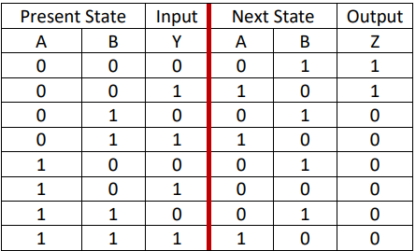

- Sate diagram

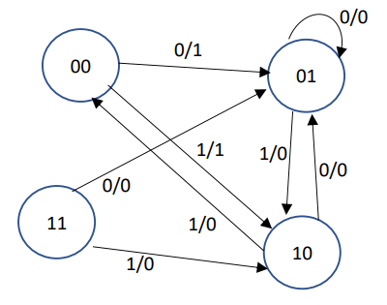
- Wareform set value

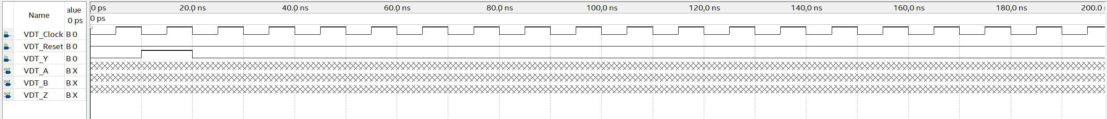

- Wareform result

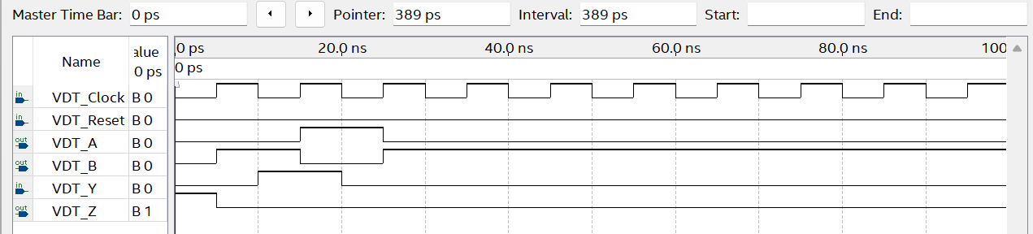

Assignment 2:
- State table
Present State |  | Input | Next state |  | Output
A | B | Y | DA | DB | Z
0 | 0 | 0 | 0 | 0 | 0
0 | 0 | 1 | 0 | 1 | 0
0 | 1 | 0 | 0 | 0 | 1
0 | 1 | 1 | 1 | 1 | 0
1 | 1 | 0 | 0 | 0 | 1
1 | 1 | 1 | 1 | 0 | 0
1 | 0 | 0 | 0 | 0 | 1
1 | 0 | 1 | 1 | 0 | 0
DA = YA +YB DB= Y.A’ Z= Y’A+Y’B
- State diagram
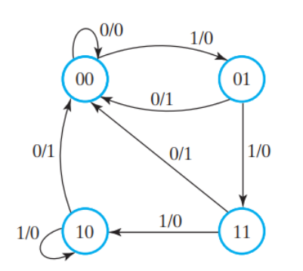
- Logic diagram
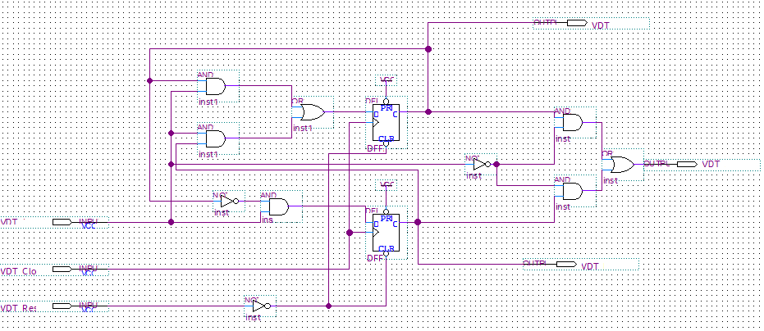
- Wareform set value
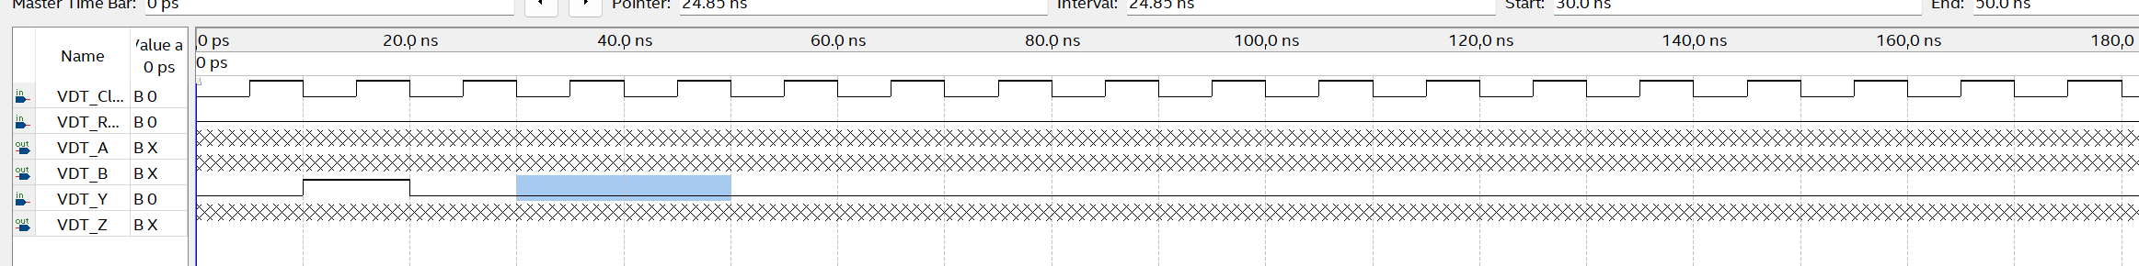
- Wareform result
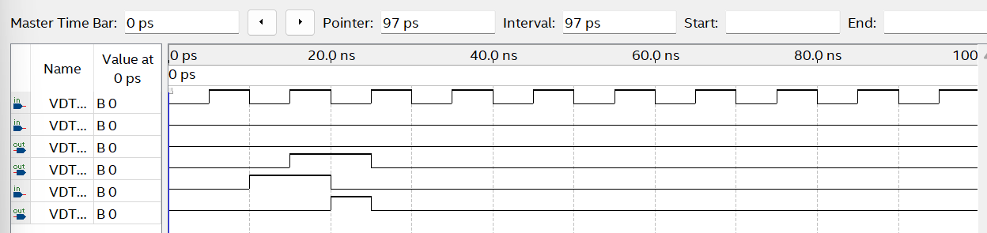

Assignment 3 : DA= XA + X’Y’ , DB = XB+XA
- Logic diagram
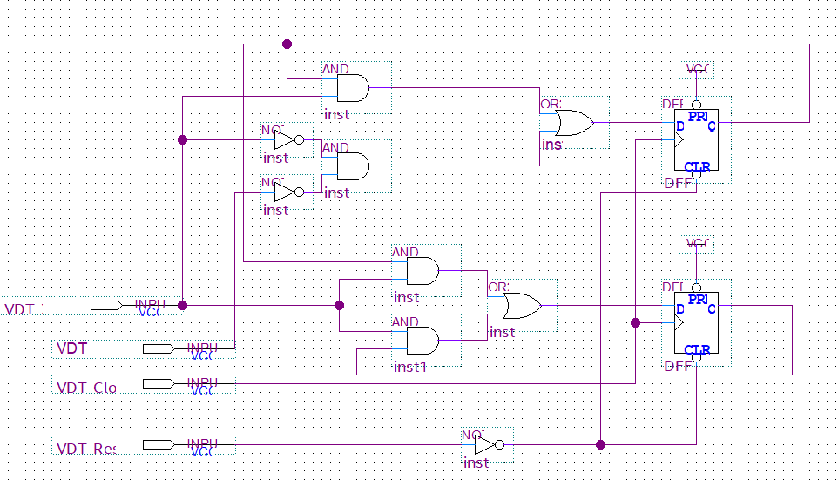

- State table
Present State |  | Input |  | Next state
A | B | X | Y | DA | DB
0 | 0 | 0 | 0 | 1 | 0
0 | 0 | 0 | 1 | 0 | 0
0 | 0 | 1 | 0 | 0 | 0
0 | 0 | 1 | 1 | 0 | 0
0 | 1 | 0 | 0 | 1 | 0
0 | 1 | 0 | 1 | 0 | 0
0 | 1 | 1 | 0 | 0 | 1
0 | 1 | 1 | 1 | 0 | 1
1 | 0 | 0 | 0 | 1 | 0
1 | 0 | 0 | 1 | 0 | 0
1 | 0 | 1 | 0 | 1 | 1
1 | 0 | 1 | 1 | 1 | 1
1 | 1 | 0 | 0 | 1 | 0
1 | 1 | 0 | 1 | 0 | 0
1 | 1 | 1 | 0 | 1 | 1
1 | 1 | 1 | 1 | 1 | 1

- State diagram
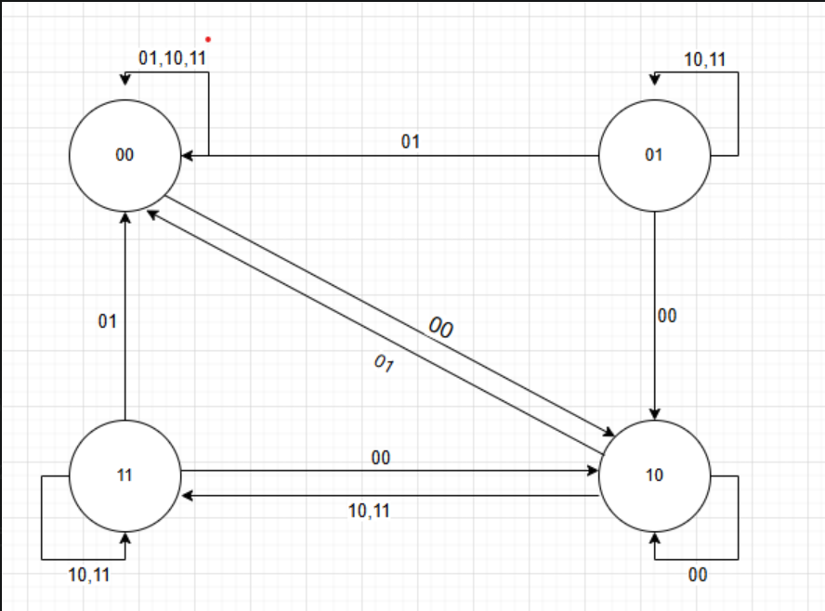
- Simulation
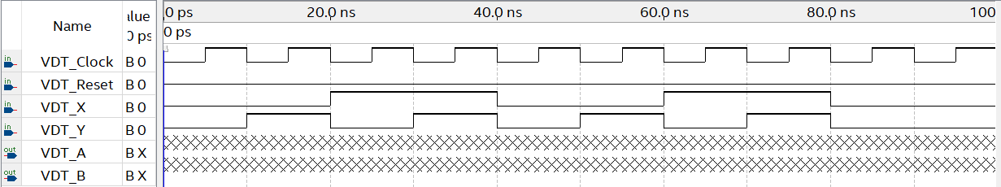

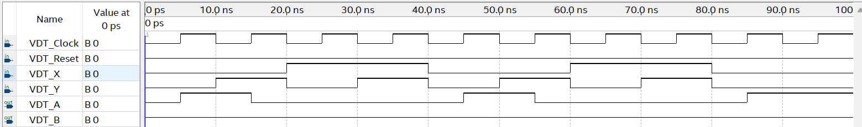

Assignment 4:
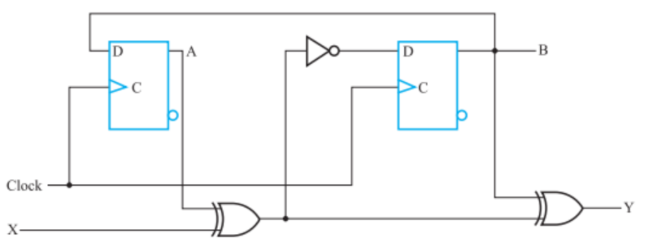
- State table
A | B | X | DA | DB | Y
0 | 0 | 0 | 0 | 1 | 0
0 | 0 | 1 | 0 | 0 | 1
0 | 1 | 0 | 1 | 1 | 1
0 | 1 | 1 | 1 | 0 | 0
1 | 0 | 0 | 0 | 0 | 1
1 | 0 | 1 | 0 | 1 | 0
1 | 1 | 0 | 1 | 0 | 0
1 | 1 | 1 | 1 | 1 | 1
DA = B DB= XNOR(A,X) Y = X XOR A XOR B
- State diagram
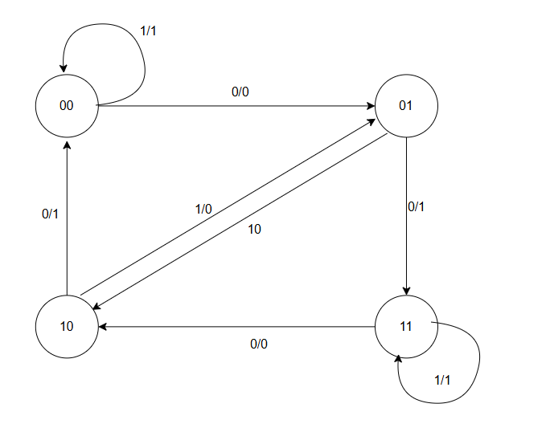
Assignment 5:
- Derive the state diagram
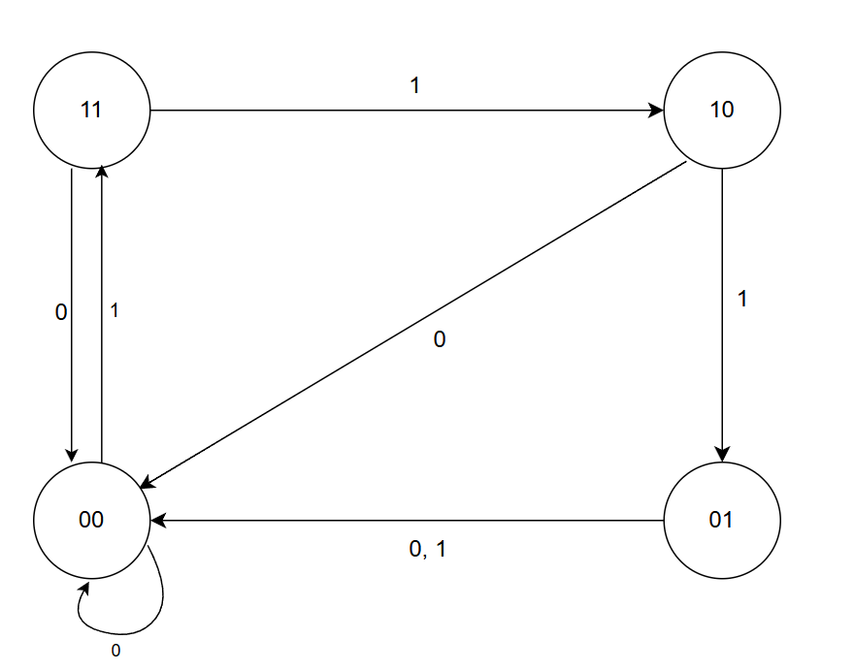

- Derive the state table
A | B | X | DA | DB
1 | 1 | 1 | 1 | 0
1 | 1 | 0 | 0 | 0
1 | 0 | 1 | 0 | 1
1 | 0 | 0 | 0 | 0
0 | 1 | 1 | 0 | 0
0 | 1 | 0 | 0 | 0
0 | 0 | 1 | 1 | 1
0 | 0 | 0 | 0 | 0

AB / X | 0 | 1
00 | 0 | 1
01 | 0 | 0
11 | 0 | 0
10 | 0 | 1
- Derive the necessary equations
AB / X | 0 | 1
00 | 0 | 1
01 | 0 | 0
11 | 0 | 1
10 | 0 | 0

DA = A’B’X + ABX DB = B’X
= X ( A XNOR B)
- Draw the logic diagram of the circuit
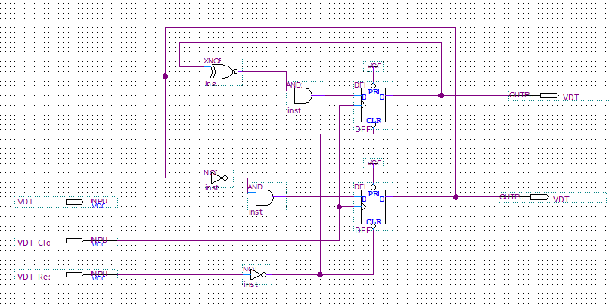
- Simulate the circuit with the following requirements
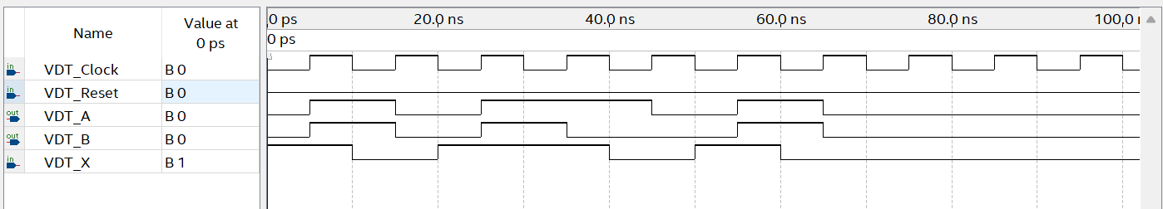

Assignment 6:
- Derive the state diagram.
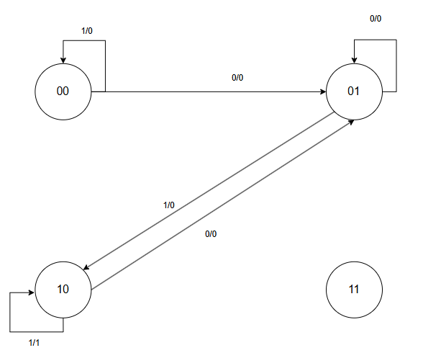
- Derive the state table.
A | B | X | DA | DB | Y
0 | 0 | 0 | 0 | 1 | 0
0 | 0 | 1 | 0 | 0 | 0
0 | 1 | 0 | 0 | 1 | 0
0 | 1 | 1 | 1 | 0 | 0
1 | 0 | 0 | 0 | 1 | 0
1 | 0 | 1 | 1 | 0 | 1
1 | 1 | 0 | X | X | X
1 | 1 | 1 | X | X | X
- Derive simplified expressions.
DA = X ( A+B)
DB = X’
Y = AB’X
- Design the logic diagram.
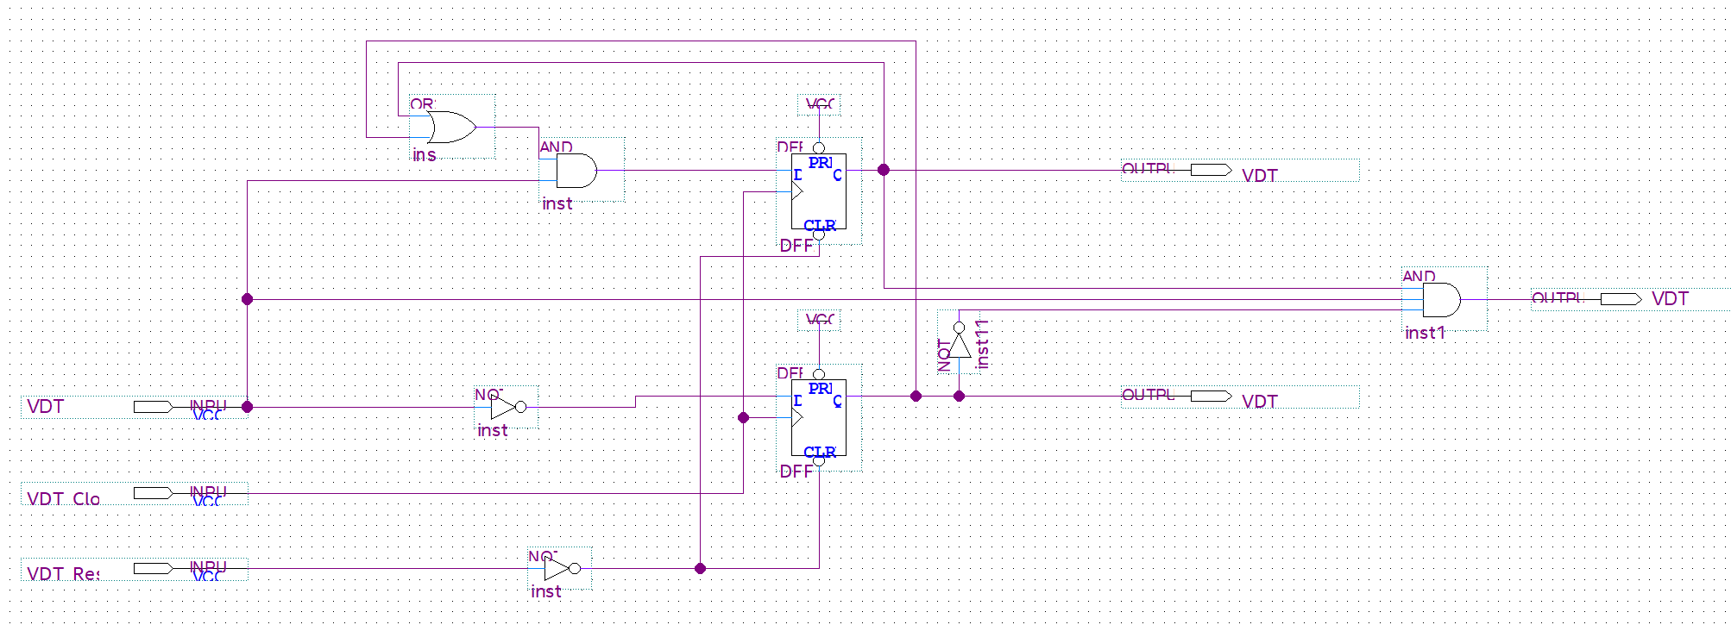
- Simulate the circuit with the following requirements.
